Dr. Vinaya Shetty
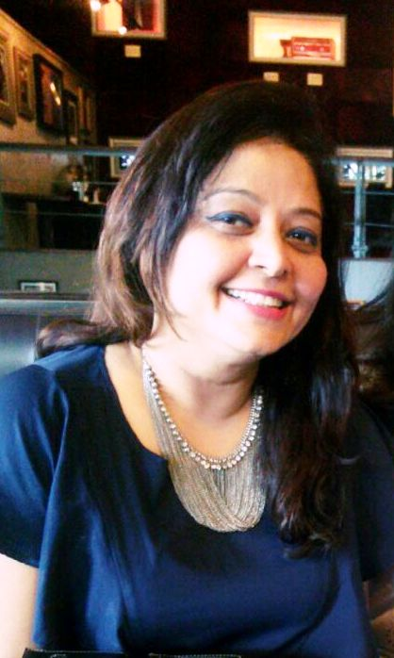

MY VISION FOR IODA

To meet the role expectations of General Vice President.
Thus, assist in creating and executing the strategy along with other Committee Members.

I do hope to considerably enhance the collaboration effort with OD Bodies and those professional bodies/Networks who are major influencers to OD in Organizations & in Communities.

To assist the President in Academic initiatives & endeavor to enhance member benefits with easy access to knowledge & the vast repertoire of wisdom that exists in the IODA community.

Usage of technology in disbursing learning initiatives and sustaining an engaged member base.

People Planet Profit – make this true for IODA in every message & event. Not for profit to make profits and distribute it for larger causes. So, making profit and being a not for profit are inextricably intertwined.

I have been the beneficiary of scholarships and understand the tremendous value it brings. Would be my endeavor that we encourage more and more people to experience IODA through its scholarship scheme.

Every Committee Member has volunteered to serve IODA and together it is our responsibility to deliver to every member, so work closely with the core team at IODA to multiply our efforts.

Dr. Vinaya Shetty – Profile
Dr. Vinaya Shetty is the Founder & President of VIN Management Consultants Pvt Ltd., having 25 years of experience in the following areas:
Strategic HR, OD & Career Consultant, with specific expertise in Transformation, Change & Executive Coaching to deliver business results and to effectively impact Communities. Collaborate with leaders and stakeholders, to create strong relationships and meet ambitious outcomes to grow business performance. Proactively engages in building a work culture that facilitates talent to outperform and realize their potential.
Strategic thinker with ability to develop and implement leadership and organizational learning programs and plans. Effective change leader and Coach, with attention to the dynamics of organizational change.
Highly innovative and results-driven individual with orientation towards practical practices for Leadership & OD interventions.
Facilitated several employee engagement and recognition platforms as part of building a vibrant culture and employee happiness.
Partner with Business leaders to align & link development plans to strategic business performance objectives.
Industry agnostic and have expertise in facilitating start-ups, SMEs & Family run businesses. Industries range from Information Technology, Telecom, Manufacturing, Media & Entertainment, Law Firms, Retail, Digital Technology.
First Indian Woman Entrepreneur Finalist, for the prestigious UNCTAD Empretec "Woman in Business Award”, 2016. Twelve finalists were selected for this award by an UNCTAD panel of experts based on the nominees showing innovation, leadership and impact in their communities
Dr. Vinaya has a Bachelor's degree in Psychology (Honors) and a Master's in Personnel Management and Industrial Relations (Tata Institute of Social Sciences). She has completed her Doctoral program from SNDT Women's University, Mumbai. The title of her thesis is "Strategic Human Resources Planning-Systems Thinking approach". She is a MBTI certified practitioner, a Facet5 certified practitioner & trainer and a certified Executive Coach. She has completed People CMM (version 2) by Tera Quest and has been certified on Strategic and Systems Thinking Tools by Haines Centre of Strategic Management, USA.
Performance & Executive Coaching: Dr. Vinaya has been certified by Results Coaching as an Executive Coach. She has completed her Appreciative Coaching from Fielding University, USA. She has been a Coach to CEOs as well as to the direct reporters to the CEO.

Dr. Vinaya has been Co -Chair at IODA India Conference, Hyderabad 2009 and was part of the Core Committee that organized yet another 3-day successful International Conference in Mysuru, for IODA India 2016.
India lead for trailing spouse assistance program by OI Partners. Largely help the spouses in understanding & adapting to the Indian culture & manage challenges during their stay in India.
Currently pursuing my final year of Law. The plan is to support Women Entrepreneurs on legal issues thru highly subsidized fees.

Work Life Balance is maintained with regular Transcendental Meditation, Yoga, Theatre, Dance (Classical Indian Dancing & Bollywood), Semi classical singing and playing the Tabla (Indian drum instrument).

Volunteer to assist Senior Citizens in the community to fight depression & loneliness.

Dr. Vinaya Shetty

India, July 2018

Endorsement – Mohanakrishnan Raman

Please consider this mail as a letter of recommendation for Dr Vinaya Shetty's candidature for the position of General - Vice President of IODA, which is in due now.

I know Vinaya from 2006. She has volunteered herself in supporting the first even conference of OD in India, organized at the SDM - Institute for Management Development (IMD), Mysore, India, with the mentorship of late Prof. Udai Pareek. She has helped in finding sponsors and also presented her paper in the conference. She was a Co-Chair for the IODA conference in 2009 in Hyderabad, India and guided the whole conference with her leadership qualities from the end to end of the entire process of organizing the conference. She was a member of IODA from 2007 and also participant and speaker in Ghana IODA Conference in 2008. She was also part of 2016 IODA conference in Mysore and part of the promotion team in 2015 in Portland USA, ODN-IODA conference. This is a direct contribution by her to the IODA community and conferences.

However, she has other decorations professionally and academically. She has the highest degree in education and a consultant in strategic HR and OD space for more than two decades. She is also trained by the Empretec a flagship program of UNCTAD for women entrepreneurship & was the first Indian woman entrepreneur nominated for the Woman in Business Award, 2016.

Vinaya will be an asset for IODA if she is elected as a GVP and I have no doubt in sending the recommendation letter in support of her candidature for the position of GVP.

I wish her a great success and also the wishes for the wing in IODA election.

Sincerely,
Dr R Mohanakrishnan

India, July 2018

Endorsement - Peter Kalmar
Dear IODA members,
It is my privilege to recommend Dr. Vinaya Shetty in this year’s election for the position of General Vice President of IODA and the shortest possible summary of why I recommend her is that I am absolutely sure Vinaya will do a great job in this position and she will be a reliable and hardworking member of the Executive Committee team.
I have met and spent time with Vinaya at several IODA Conferences, where her commitment, optimism and creativity came across in basically every moment of these events. It was obvious for me from the first moment on that her energy is viral and that on top of what she already does in her own circles in India and beyond, she could do a lot for strengthening the international IODA Community too.
It’s worth mentioning that Vinaya was indeed one of the engines behind our last IODA Conference in India in 2016 and that her contribution to the professional quality and the overall atmosphere of that event was invaluable. Dr. Vinaya is a charismatic and respected professional who moves and inspires her audience as if it was the easiest thing on earth. In dealing with people she leaves no one untouched, her messages are deep, clear and meaningful, at the same time - thanks to her outstanding sense of humor - she is just so much fun to watch and be with.
Our bylaws say that the General Vice President - together with the President of IODA - needs to strengthen IODA in the world. It also says that he/she shall provide creative ideas for developing the organization and represent it internally and externally as well. I think if Dr. Vinaya was elected now, she would be more than capable of performing these tasks and more, as her commitment to IODA is strong and her courage and personal power will support her all along the way.
Dear All,
In essence I am convinced that Vinaya can and will brings fresh ideas and energy into IODA and the daily work of the Executive Committee. So - to conclude - I am sure that she will live up to her commitment, our expectations and the trust IODA Members will put in her during this election.
Best regards:
Peter

Peter Kalmar
Former President of IODA
Hungary, July 2018

