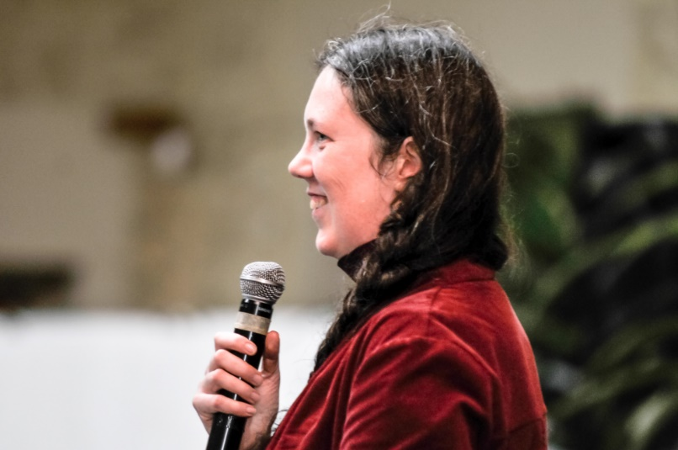

Motivation letter for Michelle de Bruyn
Since the 2005 IODA conference in Guanajuato, Mexico, IODA has become part of my identity. Having been involved in IODA most of my adult life, I feel that the values of this unique organisation and community have shaped me and are now in my blood. It is a global network that feels more like home for me than any other group of people. I am therefore committed to continuing to contribute to keeping IODA vibrant and sharing IODA values and insights with the wider world.
I do not take this potential role lightly, as I understand the challenge of working effectively together effectively in this highly diverse and volunteer-driven organisation. I have volunteered and served in various roles within IODA over the years and know the responsibilities it would bring. I am currently serving on the Silverman Endowment Committee. I have previously served on the executive committee as the Young Professionals Coordinator. I also volunteered for many years on the IODA Newsletter team. I served as co-chair for the IODA conference last year in Stellenbosch; this was a very demanding role, and required working with a mostly voluntary team, but it also reminded me of how special IODA is. Even more than ever, the IODA purpose and values are relevant to our global context.
In addition to my high level of commitment, I feel I can bring specific skills and competencies that are relevant to the role. For the past 15 years, I have worked in strategy development and building multi-stakeholder partnerships for action. My work in economic development deals regularly with multi-cultural and multi-stakeholder teams. I can also serve as a bridge between OD and other fields, including economic development and public policy.
If elected, I would be honoured to serve IODA as General Vice President.
Michelle de Bruyn
South Africa, July 2018
Michelle de Bruyn – Profile
Managing Director, Kaiser Economic Development Partners, South Africa
Michelle has consulted to both the public and private sectors across Africa and the Middle East. She has extensive expertise in multi-stakeholder processes. She is an expert in economic policy and strategy development and has managed over 70 economic development projects. In addition to OD work, her content specialisations include sector development, SMME support, design and innovation, and spatial economic development.
Michelle’s previous work experience included being a policy drafter and coordinator for the South African Department of Trade and Industry’s Executive Management Unit, Trade and Industry Chamber Coordinator at the National Economic Development and Labour Council (Nedlac), and youth leadership development coordinator at the J&J Leadership Development Institute.
Michelle holds a Master degree in Public and Development Management.
Country experience:
Botswana, Burkina Faso, Côte d’Ivoire, Democratic Republic of Congo, Ghana, Guinea, India, Kenya, Lesotho, Liberia, Mozambique, Mali, Nigeria, South Africa, Zambia

Endorsement by Karen Davis
It is with enthusiasm and confidence that I support Michelle de Bruyn’s nomination for General VP of IODA!!! She indeed fulfils all the objectives and characteristics expected in that role. Her varied experiences and personal style more than encompass the purposes of this IODA role.
It was in Mexico in 2005 that I first met Michelle at her premiere IODA conference experience. She was a young woman who came with her mother Ruth, who was a long-standing and active IODA member from South Africa. After the conference I had the delights of doing some touring with them and Lily Mitchell, also from South Africa. Seems Michelle got the “IODA bug” and has been involved in multiple ways since, for example, as a volunteer and team player, as a leader in strategically and creatively implementing a focus on new/young OD professionals, as a member of Executive Committee, as co-chair of 2017 IODA conference – to name but a few achievements.
Consistently I have appreciated Michelle’s “being”, depth, caring, responsiveness, thoroughness, dependability, and much more.
Over the years we have continued to be in touch, including sharing Angel’s Tears (South African wine) and other gems of South Africa.
I asked Lily Mitchell - who has known Michelle and family long before me - if she had any words of support for Michelle’s nomination. I totally concur with what she stated:

“I really am so thrilled that Michelle has embraced IODA, its goals and mission with enthusiasm.
Her mother, Ruth, introduced me to IODA all those years ago and it was and continues to have been a life-changing experience for me. I am so rewarded that Michelle carries the flame of enthusiasm for IODA that Ruth and I shared.
Michelle is well grounded, well experienced and forward thinking to provide the visionary leader that IODA deserves.
As such a leader, Michelle will introduce a new and fulfilling era for IODA, while being respectful of the traditions and achievements of the past.”

What more can either of us say to show our passion and trust in Michelle as General Vice President of IODA?
In gratitude, respect and peace,
Karen J. Davis
United States, July 2018

Endorsement by Alette Vonk
It is with great pleasure and eager expectancy that I would like to recommend Michelle de Bruyn for the position of Vice-President of IODA.
One of the first words that come to mind, thinking about Michelle, is: steady. She’s a steady worker, you can lean on her, count on her and there’s no drama that gets in the way. In the role of Vice President, she will be a wonderful asset for the EC and a reliable support for the President. Michelle is amiable and friendly, yet an independent thinker, capable of making intelligent contributions to strategic discussions in her own calm way.
Michelle and I have served in the IODA Executive Committee for two years together (2009 – 2011) and for many years on the IODA Newsletter Committee (2009 – 2016). It has always been marvelous to work with her. She’s very collaborative, always available and ready to get things done thoroughly. In the EC and in her role as the Young Professionals Coordinator she organized several events (both on- and offline) to tie the younger generation to IODA and she was a reliable source of information for young professionals. Within the Newsletter Committee she was quick in responding, editing articles and she provided valuable, inclusive and feasible contributions to our internal discussions.
Thirdly, probably needless to mention, Michelle was the first to accept organizing another IODA conference in Cape Town, South Africa in 2017. And what a great conference we had, at a wonderful location, with a good team that she had gathered around her and an enormous diverse program of speakers and artists!
In short, if there’s anybody who embodies the IODA spirit and its vision, mission and values, it is Michelle, who has followed in her lovely mom’s footsteps as a very active member of this organization. Finally, even the dancing crowd of IODA will be served, as we will continue to enjoy her belly dancing capacities!
All in all, I can highly recommend Michelle for the position of Vice President and I honestly think we, as a community, can be thrilled and thankful that Michelle is willing to continue to work for IODA.
Warm regards,
Alette Vonk
The Netherlands, July 2018

