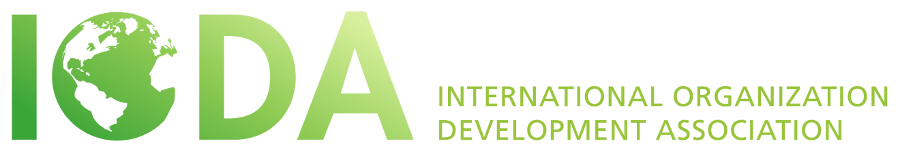
ELECTIONS 2018
POSITION DESCRIPTION
GENERAL VICE PRESIDENT
INTRODUCTION
What is IODA and what does it stand for?
The International Organization Development Association (IODA) is a non-profit membership organization and an international network of Organizational Development professionals, consultants, practitioners, students and social scientists. This non-profit association has members from many countries that initiate and support organizational change processes all over the world.
IODA is dedicated to supporting and strengthening OD principles at the international level through research, academic OD programs, peer mentoring and coaching, networking and sharing of knowledge, international projects, and cultural interchange.
IODA holds a locally organized conference in a different country every year, highlighting what OD theory and practices look like in that region, attracting world-wide thought leaders and celebrating local culture, music, food and traditions. IODA maintains community connectivity between conferences through social media platforms, webinars and unique projects enabling collaboration across the globe. Every five years, IODA hosts the OD World Summit gathering multiple OD organizations together for collaboration, learning, celebration and inspiration.
What is IODA’s purpose?
The purpose of IODA is to build a global community of OD professionals committed to inspiring learning and change around the world, unleashing human potential in organizations and communities.

IODA achieves this through:

- Sharing resources and sharpening OD practices
- Cultivating relationships and our global network
- Offering space and co-creating opportunities

… That makes a difference in the world.

What are the general commitments of members of the Executive Committee?
The primary function of elected members of the Executive Committee is to guide the association in fulfilling its vision and mission and to set all policy decisions according to the bylaws and the decisions of the member meetings.
- The Executive Committee member’s term of office is three years, beginning two weeks following the posting of the election results. There may be a period of hand-over until the annual conference.
- The Executive Committee member commits to attend the Executive Committee and larger Board/Liaison meeting held annually preceding the annual conference and the web-based meetings held quarterly.
- The Executive Committee member commits to lead working committees during the year and participating in general e-mail and one-off discussions as they arise.

ROLE DESCRIPTION
Purpose
This General VP (GVP) leadership role is a part of the Executive Committee and guides the operations of IODA.
The purpose of the role is to create and execute strategy, with the support of a volunteer team, focusing on strengthening IODA as an organization, energizing community engagement, and building relationships and collaboration with other organizations and institutions in service of IODA's purpose of co-creating the global OD community.

Specific Objectives

- Collaborate with colleagues on the Executive Committee in developing and implementing strategy regarding the leadership and operations of IODA

- Guide IODA in fulfilling its vision, mission and its values
- Help implement strategies, through volunteer teams, that enable IODA to strengthen its organization, reliability and organizational learning
- Assist the President in the implementation of policies and procedures within IODA
- In the absence of the President, the GVP will perform the duties and exercise the power of the president
- Chair of the Election Committee and Scholarship Committee
We are seeking someone:
- Who has attended at least one IODA conference and is familiar with our culture and values
- Who ideally has volunteered for IODA in the past
- Who is a good team player
- Who has skills in diplomacy and relationship-building
- With an international and multicultural orientation
- Who can draw on global network and connections to help strengthen connectivity in the global OD community
- Who honours commitments
- Able to communicate and understand English
- Who is seeking to make a difference and have fun too!

