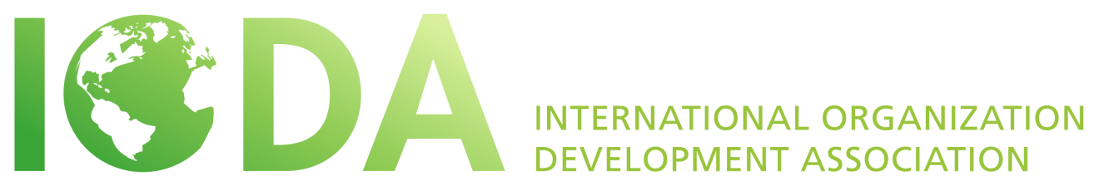
ELECTIONS 2016
POSITION DESCRIPTION
VICE PRESIDENT MEMBERSCHIP AND COMMUNICATION

INTRODUCTION
What is IODA and what does it stand for?
The International Organization Development Association (IODA) is a non-profit membership organization and an international network of Organizational Development professionals, consultants, practitioners and social scientists. This non-profit association has members from many countries that initiate and support organizational change processes all over the world. IODA is dedicated to supporting and strengthening OD principles at the international level through research, academic OD programs, peer mentoring and coaching, networking and sharing of knowledge, international projects, and cultural interchange.
What is IODA’s purpose?
The purpose of IODA is to build a global community of OD professionals committed to inspiring learning and change around the world, unleashing human potential in organizations and communities.

IODA achieves this through:

- Sharing resources and sharpening OD practices
- Cultivating relationships and our global network
- Offering space and co-creating opportunities

… That makes a difference in the world.

What are the general commitments of members of the board?
The primary function of elected members of the board is to guide the association in fulfilling its vision and mission and to set all policy decisions according to the bylaws and the decisions of the member meetings. An international and multicultural vision is important that reflects the interests and desires of OD practitioners worldwide.
- The Board member’s term of office is three years, beginning two weeks following the posting of the election results. There may be a period of hand-over until the annual conference.
- The Board member commits to attend the board meeting held annually preceding the annual world conference and the web-meetings held quarterly.
- The Board member commits to lead working committees during the year and participating in general e-mail discussions as they arise.

POSITION DESCRIPTION

Purpose
IODA is home to one the most diverse networks of OD practitioners, academics, students and those facilitating positive change in the world. We are committed to our mission of co-creating a truly global OD community. Our strength comes from our ability to create warm, welcoming, engaging and stimulating spaces for all of our members, both in person at our conferences and virtually. The VP of Membership and Communication is responsible for creating a positive, energizing, cross-cultural vision of the membership experience, in collaboration with the Executive Committee, and then recruiting and working with a volunteer task force aimed at enhancing the global member experience, bringing in new members, retaining existing members, energizing virtual connectivity and elevating the visibility of IODA.

Specific Objectives

- Enabling progress in one of the five major steps of IODA’s strategy: “Co-Creating a Strong Virtual Community”
- Establishing goals and implementing cross-cultural, global strategies for recruiting and retaining membership in collaboration with the EC and the volunteer task force
- Energizing the conversation, connectivity, mutual support and cross-fertilization of the global OD community through our website: iodanet.org as well as social media, e.g. iodacommunity.org, Face book, Linked-In, Twitter, etc.
- Energizing the global member experience
- Collaborating with and supporting the work of the Executive Committee
- Serving as representative for IODA

Criteria

- Strong leadership qualities
- Demonstrated ability to work skillfully on a team
- Passion for engaging and connecting people
- Demonstrated commitment to the mission of IODA
- Demonstrated ability to inspire and motivate
- Comfortable with the tools and possibilities of social media and tools for virtual connectivity
- Ideally, well-connected in the OD community
- Fluency in English

