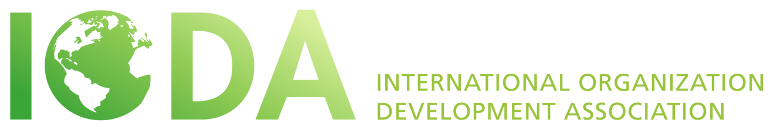
ELECTIONS 2016
POSITION DESCRIPTION
VICE PRESIDENT CONFERENCES AND EVENTS

INTRODUCTION
What is IODA and what does it stand for?
The International Organization Development Association (IODA) is a non-profit membership organization and an international network of Organizational Development professionals, consultants, practitioners and social scientists. This non-profit association has members from many countries that initiate and support organizational change processes all over the world. IODA is dedicated to supporting and strengthening OD principles at the international level through research, academic OD programs, peer mentoring and coaching, networking and sharing of knowledge, international projects, and cultural interchange.
What is IODA’s purpose?
The purpose of IODA is to build a global community of OD professionals committed to inspiring learning and change around the world, unleashing human potential in organizations and communities.

IODA achieves this through:

- Sharing resources and sharpening OD practices
- Cultivating relationships and our global network
- Offering space and co-creating opportunities

… That makes a difference in the world.

What are the general commitments of members of the board?
The primary function of elected members of the board is to guide the association in fulfilling its vision and mission and to set all policy decisions according to the bylaws and the decisions of the member meetings. An international and multicultural vision is important that reflects the interests and desires of OD practitioners worldwide.
- The Board member’s term of office is three years, beginning two weeks following the posting of the election results. There may be a period of hand-over until the annual conference.
- The Board member commits to attend the board meeting held annually preceding the annual world conference and the web-meetings held quarterly.
- The Board member commits to lead working committees during the year and participating in general e-mail discussions as they arise.

POSITION DESCRIPTION
Purpose:
To provide support to IODA’s work of creating vibrant spaces for the global OD community to interact at the annual IODA conferences and other events.

Specific objectives
- Support the President in identifying conference hosts at least 3 years in advance
- Faithfully promote and strengthen the nature and spirit of IODA conferences as the flagship event of IODA
- Negotiating the contract between IODA and the Host Country Conference Committee (HCCC)
- Reviewing the hosts’ plans, processes and program themes and providing timely feedback on conference website, communications and systems
- Acting as the main contact person with the HCCC chair
- Following up on the financial post-conference statement from the HCCC chair
- Suggesting resources and innovations in events and conferences, considering both face-to-face and virtual web based events.
- Sharing relevant conference history and guidelines with HCCC
- Initiating and supporting the initiatives of others in regional and local events
- Liaising with IODA ambassadors and regional supporters
- Develop and maintain event and volunteer databases
- Encouraging the HCCC and event organizers to make good use of social media and to collaborate with the IODA communications team.
- Cultivate relationships with new and existing members interested in running events and conferences

Preferred Criteria
- Experience in organizing conferences, ideally including international conferences
- Experience of being on an IODA conference organizing team would be beneficial
- Essential to have attended a number of IODA conferences
- Demonstrates a deep understanding and affinity for the spirit in which IODA conferences are co-created.
- Experience in serving on a board is beneficial
- Ability to work collaboratively in a team
- Able to negotiate, motivate, gather contributions, initiate ideas and innovations, make decisions and follow through
- Demonstrated leadership ability and experience
- Able to devote time in serving of the association and its aims
- Experience and expertise in OD and currently active in that field
- Experience in working cross culturally
- Some knowledge and experience in use of social media is desirable
- Fluency in English

What are the overall objectives of the Vice President Conferences and Events for the up-coming three years?
- Become part of the review and learning after the India 2016 conference.
- Begin supporting the IODA conference in South Africa 2017 and Europe 2018. Confirming suggested host countries to 2020.
- As there are some new aspects to this enlarged role the VP will need to give and receive regular feedback and seek support and guidance.
- Initiate and support other events. It is envisaged that it will take some time to develop such IODA activities.

