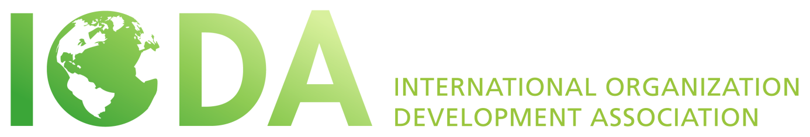

IODA Presidential Elections 2016 – Strategic Directions

The new President will lead a team that builds on 30 years of hard work, major successes and a wealth of experience to take IODA to the next level through achieving the following major strategic steps:

- MAKING THE BASICS WORK - Creating an organization that works and involves everybody who is willing to put time and energy into IODA, positioning and promoting IODA actively, using technology smarter to providing ourselves with systems and platforms that make us function effortlessly and connect us through time and space.

- BUILDING A STRONG VIRTUAL COMMUNITY - Using the latest technology to communicate we make sure our members connect in between events and conferences too, we support knowledge sharing and creative collective visioning resulting in emerging initiatives and our members joining forces to execute local and global projects.

- ORGANIZING OUTSTANDING CONFERENCES AND EVENTS - Making sure our participants get the “IODA experience” at our global conferences, creating new regional and local gatherings and creative ways of connecting, getting our local chapters, members, supporters act and organize their own events in IODA style and quality.

- CO-CREATING A GLOBAL OD COMMUNITY - Reaching out to our sister organizations, looking for ways of working together with them, harmonizing, marketing, co-hosting joint events, activities, projects, programs, providing membership benefits in mutually beneficial ways to become stronger and have a significant impact on the world around us.

- LAUNCHING AND SUPPORTING MISSION DRIVEN PROJECTS - Encouraging and supporting local initiatives to emerge and turn into action, facilitating cooperation between our members and supporters to increase and enhance our local and global presence, running and promoting projects that are in line with our mission.

